
Name: Abdul Samad
Program: BSSE Group A
Semester: 5th
Date: September 18, 2026
*-----------------------------------------------*

Lab Task 2
Command Prompt Snip:

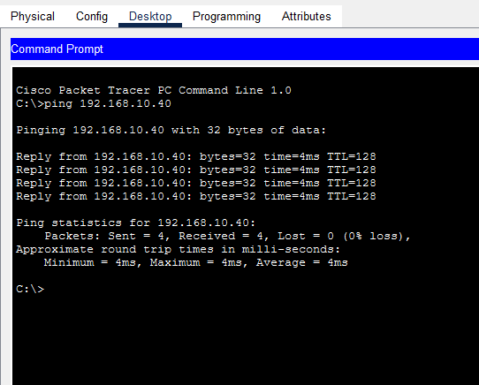

Topology Snip:

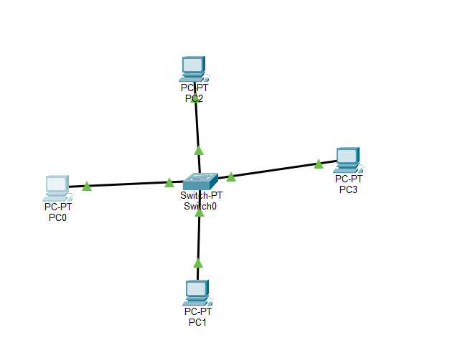

On Different Network:
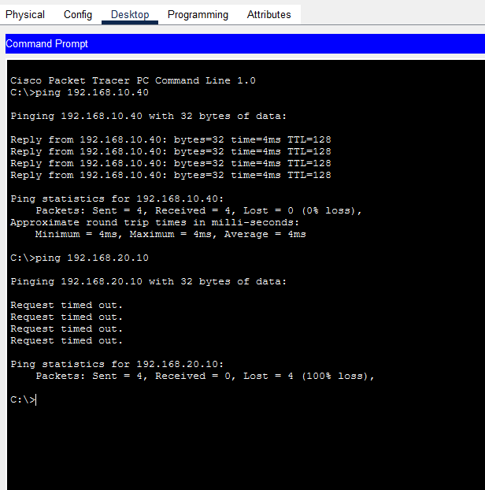
*-----------------------------------------------*

Working With Router
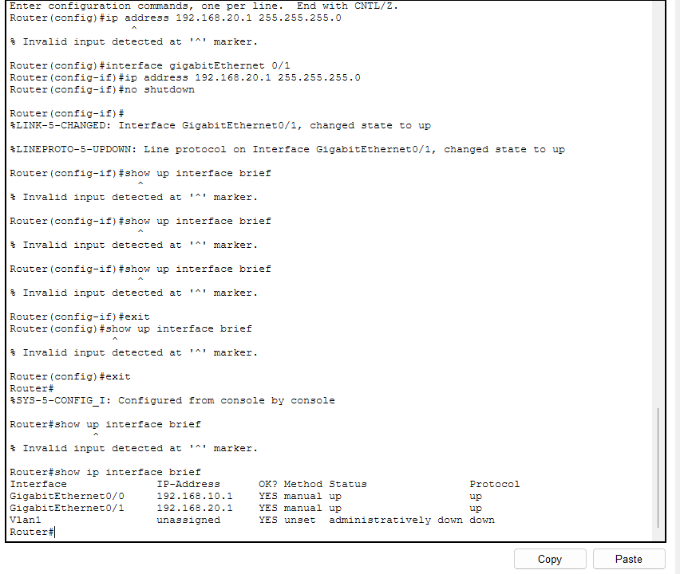

Pinging:

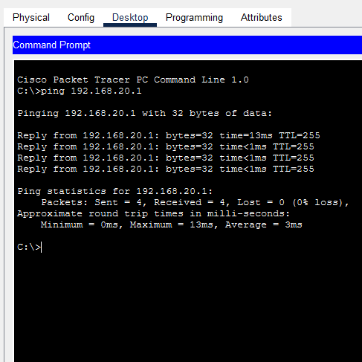

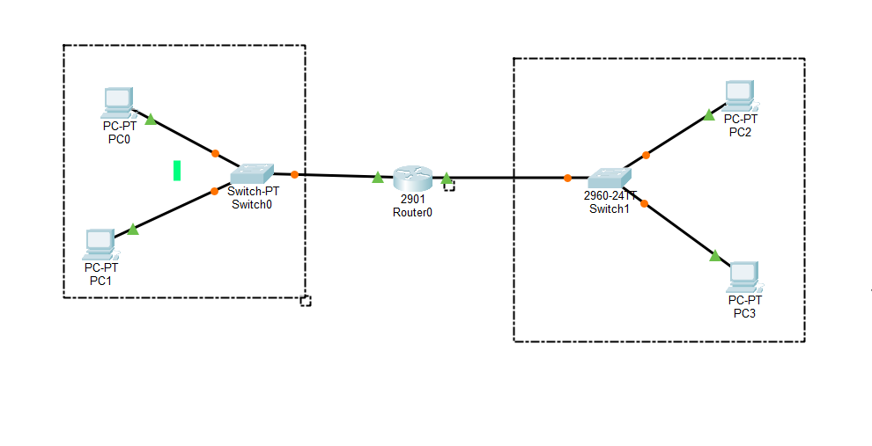

*-----------------------------------------------*

The End

